Enhancing Students’ Vocabulary Mastery by Using Kids’ Songs on YouTube for Fifth Grade Students at MI Darul Muta’allimin Patianrowo Nganjuk
Khurin Fauziah
Universitas Islam Kadiri, Indonesia
khurinfauziah8@gmail.com)

ABSTRACT
Vocabulary mastery plays an important role in English learning because it serves as the foundation for developing students’ language skills, including listening, speaking, reading, and writing. Many elementary school students still experience difficulties in understanding and remembering English vocabulary due to limited exposure and less engaging learning activities. The integration of digital learning media such as YouTube-based educational content may provide a more enjoyable and effective learning experience for young learners. This study aimed to investigate whether the use of kids’ songs on YouTube could significantly enhance students’ vocabulary mastery among fifth-grade students at MI Darul Muta’allimin Patianrowo Nganjuk. The study employed a quantitative approach using a pre-experimental design with a one-group pre-test and post-test design. The participants of this study consisted of 21 fifth-grade students. The research instruments were vocabulary pre-test and post-test consisting of multiple-choice and fill-in-the-blank items. The collected data were analyzed using descriptive statistics, a normality test, and a paired sample t-test. The findings revealed that the mean score increased from 21.90 in the pre-test to 73.24 in the post-test. The paired sample t-test result showed a statistically significant difference between the pre-test and post-test scores with t(20) = 10.52 and p < .001. The findings indicate that kids’ songs on YouTube significantly enhanced students’ vocabulary mastery and can be considered an effective instructional medium for vocabulary learning among young learners.
Keywords: vocabulary mastery, kids’ songs, YouTube, young learners, English learning.

INTRODUCTION
The development of digital technology has changed the way children access information and learn new knowledge in everyday life. Young learners now interact with videos, songs, and visual content on a regular basis through mobile devices and online platforms. YouTube has become one of the most familiar digital spaces for children because it combines audio, visual, and repetitive language input in a form that feels entertaining rather than burdensome. In language learning, such multimodal exposure can be beneficial because children tend to absorb vocabulary more easily when words appear in meaningful, attractive, and repeated contexts. Recent studies suggest that multimedia learning supports vocabulary acquisition through dual channels of processing, which helps students understand and remember new language more effectively (Mayer, 2024; Li et al., 2022). This condition makes digital media increasingly relevant for vocabulary instruction among young learners.
Vocabulary mastery remains one of the most important foundations in English learning. Students need vocabulary to understand instructions, express ideas, build sentences, and develop other language skills such as listening, speaking, reading, and writing. Learners with weak vocabulary knowledge usually struggle to follow classroom explanations and often lose confidence when they are asked to use English actively. For elementary school students, vocabulary learning needs to be enjoyable, concrete, and repeated because children learn better through attention, imitation, and meaningful exposure. Traditional rote memorization often makes vocabulary learning feel difficult and less engaging. Studies on children’s songs and multimedia-based instruction show that enjoyable input can improve both vocabulary retention and learning motivation (Putri & Rustipa, 2023; Kholid et al., 2024).
The role of technology in English language teaching has become more visible in recent years, especially after digital learning tools became more common in formal education. YouTube is not only used for entertainment, but also for learning content that can support vocabulary growth in children. Research has shown that YouTube-based instruction can provide multimodal and contextual input that helps young learners recognize, retain, and recall vocabulary more effectively (Tohamba, 2025). In addition, audiovisual media can help teachers present words through pictures, pronunciation, movement, and song in one integrated activity. This is especially useful for elementary learners who still depend heavily on concrete examples and repetitive exposure. English learning media that combine sound and visual stimulation are therefore considered suitable for classroom use at the primary level (AL-Ameri & Rababah, 2020; Anggraini et al., 2022).
Kids’ songs on YouTube are particularly relevant for vocabulary teaching because they naturally contain rhythm, repetition, and simple language structures. Repetition helps children notice and remember words, while melody strengthens memory through familiarity and pattern recognition. Songs also create a relaxed atmosphere that may reduce anxiety and increase student participation during class. Previous research has reported that songs can make vocabulary learning more meaningful because children enjoy the activity and are more willing to repeat the words they hear (Putri & Rustipa, 2023; Zhang et al., 2023). Other studies also indicate that song-based instruction can support not only word recognition but also pronunciation and form-meaning connection (Tilwani et al., 2022). These findings suggest that songs are not only entertaining, but also pedagogically useful for vocabulary instruction.
Several recent studies have examined the use of songs, YouTube, and digital media in vocabulary learning. Kholid et al. (2024) found that English kids’ songs improved vocabulary mastery among primary students and increased their learning motivation. Zhang et al. (2023) also reported that singing-based instruction produced stronger vocabulary gains than spoken-word instruction in an ESL context. Putri and Rustipa (2023) showed that songs were very effective for young learners because students could remember vocabulary more easily and participate actively in class. A systematic review by Hamilton et al. (2024) also confirmed that songs are widely used in language learning research, although the review emphasized the need for stronger intervention designs. These studies demonstrate that songs and multimedia resources can support vocabulary development in elementary learners.
Other research has focused on broader digital media and multimedia-based vocabulary learning. AL-Ameri and Rababah (2020) reported that YouTube use significantly improved elementary students’ vocabulary achievement. Anggraini et al. (2022) found that the Cocomelon YouTube channel could help introduce children’s English vocabulary through attractive audiovisual content. Anggaira et al. (2022) also concluded that songs are effective as learning media for young children because they match children’s learning characteristics. Li et al. (2022) explained that multimodal input contributes to vocabulary learning because learners process verbal and non-verbal information together. These findings strengthen the argument that digital music-based media can support English vocabulary learning among young learners.
Although previous studies have shown positive results, several research gaps still remain. Many studies focus on general children’s songs or digital media without specifically examining kids’ songs on YouTube in an elementary Islamic school context. Some studies involve preschool learners, while others focus on secondary students, so fewer studies directly address fifth-grade students in MI settings. Limited research also examines short-term vocabulary growth through a one-group pre-test and post-test design in a local Indonesian school context. This means that the effectiveness of kids’ songs on YouTube in this specific setting still needs empirical confirmation. Research that investigates this topic in MI Darul Muta’allimin Patianrowo Nganjuk can therefore contribute new evidence and strengthen the existing body of knowledge.
The present study is important because vocabulary problems are still commonly found among fifth-grade students in many elementary classrooms. At MI Darul Muta’allimin Patianrowo Nganjuk, preliminary classroom observation indicated that students had difficulty recalling and using English vocabulary accurately. Some students showed low confidence and limited participation when vocabulary activities were delivered through conventional methods. The classroom atmosphere also needed more interactive and attractive media to make learning more effective. Kids’ songs on YouTube may offer a practical solution because they provide repetition, audio-visual support, and enjoyable content that suits young learners’ characteristics. This study is therefore relevant both pedagogically and contextually.
This study aims to investigate whether kids’ songs on YouTube can significantly enhance students’ vocabulary mastery among fifth-grade students at MI Darul Muta’allimin Patianrowo Nganjuk. The study is expected to contribute to English language teaching by offering evidence about the effectiveness of song-based digital media for young learners. It may also give teachers an alternative strategy for teaching vocabulary in a more interesting and memorable way. For students, the use of kids’ songs on YouTube may create a more enjoyable learning experience and support better vocabulary retention. For future researchers, the study may serve as a reference for further investigations into vocabulary learning, multimedia instruction, and digital classroom practices.
METHODS - (Arial 12 pt, Bold, Uppercase)
This section explains the research design, participants, instruments, procedures, and techniques of data analysis.
The first paragraph should not be indented, while the following paragraphs should use first-line indentation of 0.75 cm. Do not leave extra spaces between paragraphs.
Participants
Instruments
Procedures
Data Analysis

RESULTS AND DISCUSSION - (Arial 12 pt, Bold, Uppercase)
This section presents the findings of the study and discusses them in relation to theories or previous studies.
The first paragraph should not be indented, while the following paragraphs should use first-line indentation of 0.75 cm. Do not leave extra spaces between paragraphs.
Subheading 1
Subheading 2
Subheading 3

CONCLUSION - (Arial 12 pt, Bold, Uppercase)
This section contains the summary of the findings, implications of the study, and recommendations for future research.
The first paragraph should not be indented, while the following paragraphs should use first-line indentation of 0.75 cm. Do not leave extra spaces between paragraphs.

AUTHOR BIOGRAPHY - (Arial 12 pt, Bold, Uppercase)
Provide a brief biography for each author in one paragraph. Include current affiliation, academic background, research interests, and/or academic focus.
Example:
First Author is a lecturer/student/researcher at [Institution Name]. His/Her research interests include English language teaching, applied linguistics, educational technology, and teacher professional development.

CITATION - (Arial 12 pt, Bold, Uppercase)
Use APA 7th Edition style for both in-text citation and references. Authors are encouraged to use reference management tools such as Mendeley, Zotero, or EndNote.
Example of In-text Citation
- According to Benson (2010), teacher autonomy plays an important role in language learning.
- Teacher autonomy is essential in language learning (Benson, 2010).
- Direct quotation should include page number (Benson, 2010, p. 24).
If citing more than one reference, arrange them alphabetically:
(Benson, 2010; Gao, 2018).
Do not use footnotes.

Illustrations, Graphs, and Photographs
Please arrange figures in a way that important information can be caught at a glance. Illustrations, graphs, and photographs should fit in one column (see Figure 1).
Equations (whenever applicable, only for Quantitative/Mixed-method research)
Please refer to equations in the text as Eq. (1).

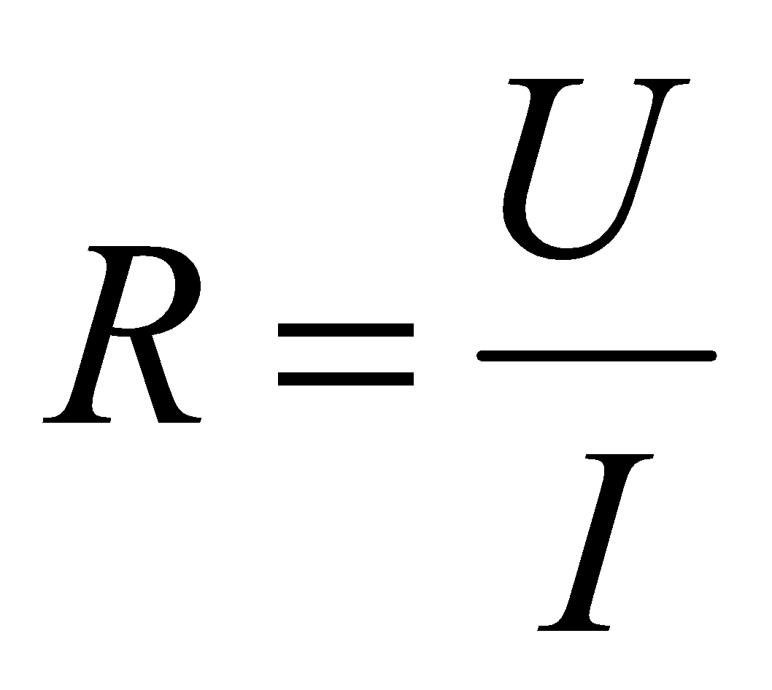 (1)
Captions (whenever applicable, only for Quantitative/Mixed-method research)
Figure and table captions should be in Arial 10 pt. italic. The caption is placed above a table and below a figure, picture, or graphic to describe important information.
Table 1: Table caption
T / °C | Sensitivity of variable towards N2O | coefficient of determination R2
300 | 0.8 | 0.9998
400 | 1 | 0.9994

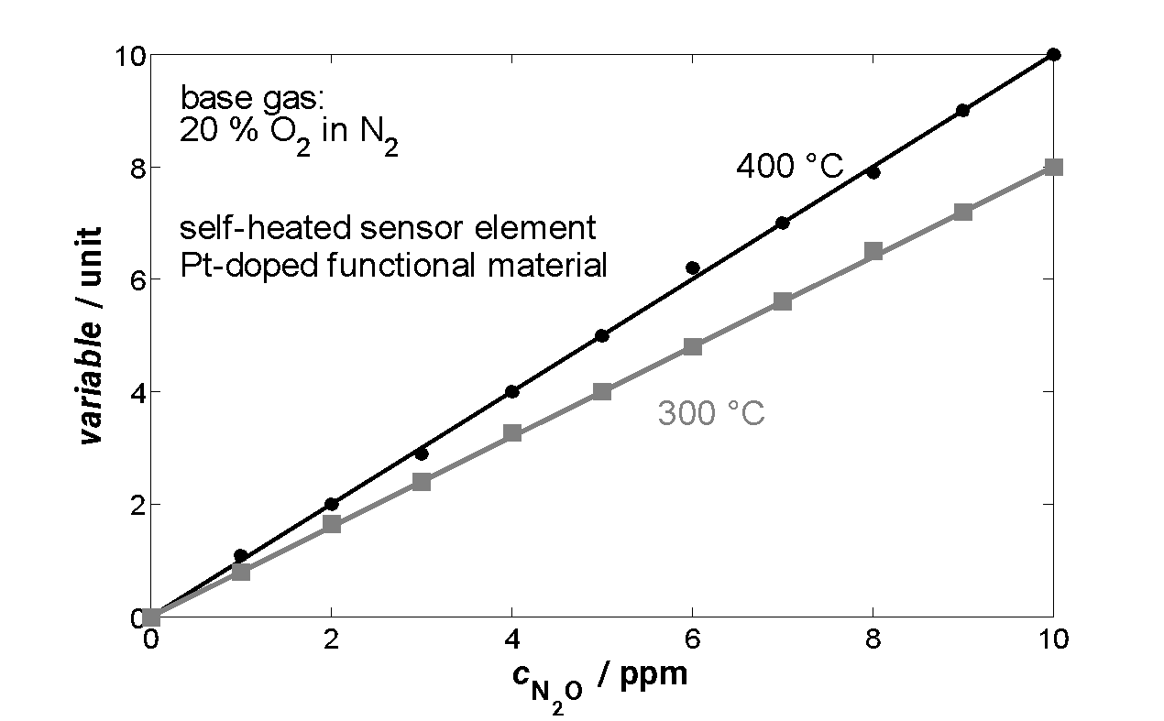

Figure 1. Example of figure placement

ACKNOWLEDGEMENTS - (Optional)
Indicate sources of funding, institutional support, or individuals who contributed significantly to the study or manuscript preparation.

REFERENCES - (Arial 12 pt, Bold, Uppercase)
Use APA 7th Edition style for all references cited in the manuscript. Authors are encouraged to use Mendeley, Zotero, or other reference management applications. The manuscript must include a minimum of 20 references.

Example of References
Benson, P. (2010). Teacher education and teacher autonomy: Creating spaces for experimentation in secondary school English language teaching. Language Teaching Research, 14(3), 259-275.
Gao, X. (2018). Language teacher autonomy and social censure. Autonomy in language learning and teaching: New research agendas, 29-49.

Format of the Paper
- The manuscript must be written in Microsoft Word format.
- Use A4 paper size with 2.5 cm margins on all sides.
- Use Arial 12 pt, 1.5 line spacing, and single-column layout.
- The manuscript should consist of approximately 3000–8000 words or 8–15 pages.
- Please do not include page numbers in the manuscript.

Paper Structure
For research-based papers, authors are expected to follow this structure:
- Introduction
- Methods
- Results and Discussion
- Conclusion
- Author Biography
- Acknowledgements
- References
For literature review articles, authors may adjust the structure according to the needs of the paper.

Ethical and Originality Statement
Authors are fully responsible for the originality of their manuscripts. All sources must be properly cited. Any use of AI-assisted tools should be acknowledged appropriately when necessary.

Submission
Papers should be submitted as a Microsoft Word document via the ICELS OJS submission system. Submission details will be announced later.
Submission deadline: June 4th, 2026.

